34.23: For 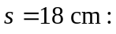
a) 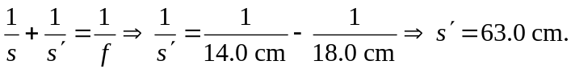
b) 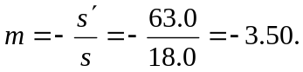
c) and d) From the magnification, we see that the image is real and inverted.

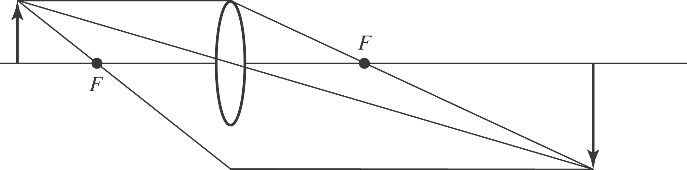

For 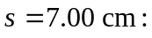
a) 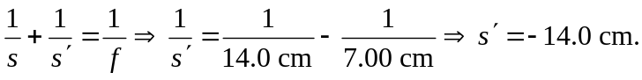
b) 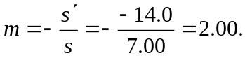
c) and d) From the magnification, we see that the image is virtual and erect.

